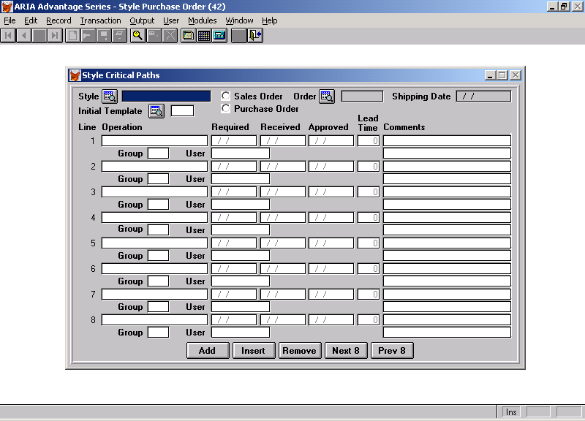

This is a copy of the screen where you attach Critical Path Template Codes to a Style that is on a Sales or Purchase Order and then can track the operations and edit the
Particular Path. We do not need the received column, which allows the addition of a column “Auto Recalculate { } Y/N”.

Again this is a sample layout and we would suggest a few changes – mainly adding an option to add a notepad to a complete template on the top taskbar, an option to add a notepad to each operation line and an option to add Objects to a particular Template.

The way the system should work would be as follows:

- The user selects a valid style from a style browse
- The user decides if he is to link the template to a Sales Order or a Style Purchase Order.
- Once this has been selected – he will then pick either a Sales Order or Style Purchase Order dependant on the choice on point 2. This automatically fills in the Shipping Date – which is the Start Date for a Sales Order and the Complete Date for a Style Purchase Order. This date can be edited – but does not update the original Order.
- The user then browses for an Initial Template Code – which is picked up from the available Critical Path Templates as per the 1st Document ( cpa template screen.doc)

Once the template Code has been selected then the individual operation lines are filled up from the lines on CPA template except the Required Date ,Approved Date and the Comments which are left empty.

The Required Date is Calculated as follows:

Working from the last Operation on the Template – look at the lead time(which is a number of days) and work backwards from the Shipping Date. For example if the Shipping Date is 10/10/2001 and the lead time for the first operation is 7 days – then the required date would be 03/10/2001 for the last operation. If the lead time for the 2nd to last operation is 5 days – then the required date for that operation would be 29/09/2001 – and so on until the first operation has the required date filled in. The only exception to this would be any operation that has the auto-recalculation flag set to “N” – in which case this operation is skipped and ignored from the recalculation of required dates (the user will fill these dates in manually)

Apart from the normal tool bar functions of Edit, Update, Delete etc. the following extra functions are required which only amend the Style Critical Path being created (not the original template).

Add – takes you to the next free line to add a new entry
Insert – allows you to insert a line below the line on which the cursor is placed.
Remove – removes the line highlighted by the cursor
Next 8 – takes you to the next screen of 8 items
Prev 8 – tales you to the previous screen of 8 items

Once the Critical Path has been saved then the user will be allowed to edit it at any time to add comments, notes, objects, approved dates etc.

They will also be allowed to amend dates as follows:

- If the Shipping Dates are changed – then the system will ask the user if they want to recalculate any required dates that have not been approved. If the user says Yes then the recalculation will start at the last operation and recalculate any required date for any operation that has not had the approval date filled in. Any Operation with the Auto-Recalculation set to “N” will be ignored. If the user says “N” – then no recalculations take place.

- If the user changes a Required Date for a particular operation – the user will be asked if they wish to recalculate all the Required Dates for all operations below it in the Critical Path. If the user says Yes – then all unapproved operations below the one being changed will have their required dates recalculated. This should not change the Shipping Date !!! Any Operation with the Auto-Recalculation set to “N” will be ignored. If the user says “N” – then no recalculations take place.

Validations:

Groups Codes must be validated against the new Critical Path Codes entry in the CODES file
Users must be validated against the SYUUSER file.
You cannot change the required date of an operation that has an approval date filled in

Other Points:

There will be a new File created to hold the Style Critical Path points – as well as the fields noted on the screen example – another field will need to be added to the file which is single character alphabetic field – “Added to User Todo Schedule “ which will be preset to “N” and cannot be changed through this program.

There will also need to be another field “To do sequence no” which will be linked to SYSCHDUL.CSEQNUMBER – which will be set to spaces.
The 3rd document in this series (cpa link to user schedule.doc) – specifies linking these operations to the SYSCHDUL file.
When an approval date is entered against an operation – if the “to do sequence no” has a valid entry to an incomplete SYSCHDUL record then this should be automatically completed using the Aria System Date.

